Standard deviation and five number summary calculations

In the following problems we will examine how to calculate the standard deviation by hand. The purpose of these exercises is to gain a better understanding of the formulas/notation for computing the standard deviation (and to learn to be thankful that we have computers!).

The number below show the number of hot dogs eaten by the winner contestants in the Nathan’s Famous hot dog eating contest. Please use the steps below to compute the standard deviation for this data.

Year | Hot Dogs
2011 | 62
2010 | 54
2009 | 68
2008 | 59
2007 | 66
2006 | 54
2005 | 49
2004 | 54

The formula for the standard deviation is:

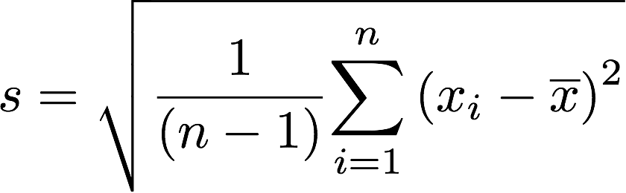

Please use this formula for exercises 1 and 2.

Part 1: Calculate the the standard deviation using the steps below (you can use R but you must fill in the full table showing all intermediate steps)

- Fill in the number that is the mean of the hot dogs eaten
- Fill in the column that is the deviations of each data point from the mean, i.e., x_{i} – x̅
- Fill in the squared deviations
- Fill in the sum of squared deviations
- Fill in the sum of squared deviations divided by n-1
- Fill in the square root of the sum of squared deviations.

Num hot dogs | b. Deviations (x_{i} - x̅) | c. Deviations squared (x_{i} - x̅)²
62
54
68
59
66
54
49
54
a. mean = _______

d. Sum of squared deviations: Σ (x_{i} - x̄)² = ________
e. Sum of squared deviations divided by n – 1: Σ (x_{i} – x̅)² /(n-1) = ______
f. Take the square root to calculate s: sqrt( Σ (x_{i} – x̅)² /(n-1)) = _______ = s

Part 2: Use the extended hot dog data below that includes data from 2012 and 2013, and calculate the following statistics (Hint: Start by sorting the data).

- The five number summary =

- The range =

- The interquartile range (IQR) =

Year | Hot Dogs
2013 | 69
2012 | 68
2011 | 62
2010 | 54
2009 | 68
2008 | 59
2007 | 66
2006 | 54
2005 | 49
2004 | 54

